CINDERELLA TRANSFORMATION DRESS
The two ragged dresses are identical (we dirtied ours up, however it’s clean now so doesn’t look it). You could also add more patches, etc. The dress with the ball gown under is too bulky to wear the entire time, that’s why two dresses. She was able to make a quick change shortly before the pumpkin patch scene.
#1 Ragged Dress #2 Dress unties at the shoulders. #3 Front came down. She did this
She did this on a turn when her on the 2nd turn around when her
back was to the audience. back was to the audience.
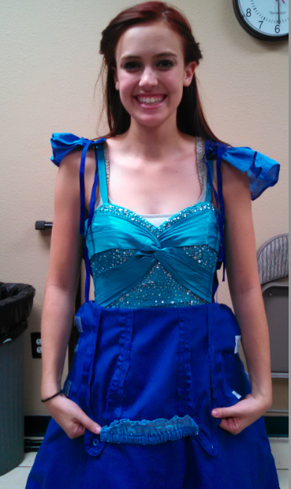
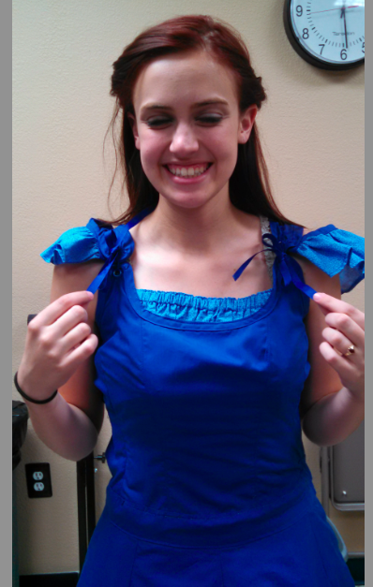
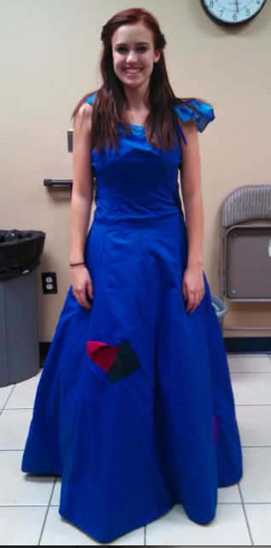

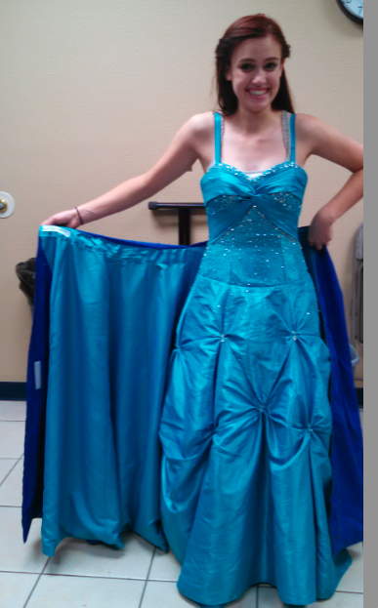
#4 She easily unwrapped it during a #5 She dropped the ragged dress
turn around. As you can see the inside behind her and stepped out of that area
is lined with the same color as the ball toward the Fairy Godmother. As she
gown. dropped it, more fog was generated .
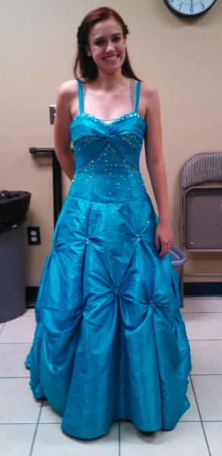

fdf

Between the fog, strobe, and metallic confetti, it was very effective. She was near the edge of a corner stage so we could easily pull the ragged dress off while more fog was generated and she moved toward the Fairy Godmother. After she left in the carriage, she added another slip underneath for the ball. We added long gloves, sparkly jewelry, hair up w/tiara.

