HONORING OUTSTANDING WORK IN
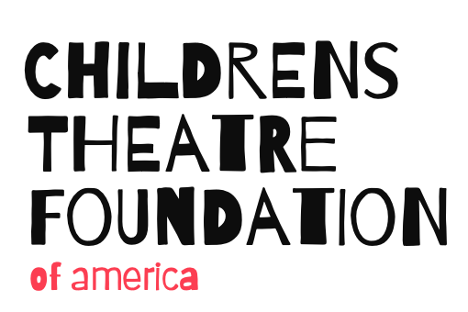
PUBLIC HIGH SCHOOL THEATRE EDUCATION
The Children’s Theatre Foundation of America Seeks Nominations for the 2022 REBA R. ROBERTSON AWARD
The biennial Reba R. Robertson Award recognizes EXCELLENCE in the important work of public high school theatre/drama teachers throughout the United States of America.
The Reba R. Robertson Award features:
- $5000 to the honoree to use as he/she chooses for the purpose of expanding professional interests (for example: study with a master mentor, travel, research, develop learning tools)
- $1000 to the honoree’s school to enhance the high school theatre/drama program
- Two distinctive trophies, one for the honoree and one for the honoree’s school
- Transportation expenses up to $400 for the recipient to travel to the CTFA Medallion Awards Event

Award Criteria:
- A candidate must be a current public high school teacher with at least 5-8 years of service remaining.
- A candidate must exhibit:

- Strong, ongoing commitment to dismantling racism as demonstrated by a focus on diversity, equity and inclusion and involving communities that have been historically disadvantaged and socially, politically, and economically excluded.
See CTFA’s statement on equity, diversity and inclusion: http://www.childrenstheatrefoundation.org/
- Dedication to guiding high school students through curricular, co-curricular, and/or extracurricular programming in the theatre arts
- Exceptional mentoring qualities
- Broad influence on school, community, state, region and beyond as represented by the award’s namesake,
Reba. R. Robertson. Link to additional award information: https://www.childrenstheatrefoundation.org/page-8/
- Artistic achievement, innovation and artistic excellence

- Use of the award to gain new experiences, grow as a theatre educator and expand knowledge of equitable practices in high school theatre.

APPLICATION STEP ONE – Nomination
All nominations must be submitted via e-mail and received no later than December 15, 2021.
E-mail to jbgonzal246@gmail.com The nomination letter must include:

1) A brief description of the relationship between the nominator and the nominee
2) Nominee’s name, email address, phone number, and name of nominee’s high school
3) A brief rationale for the nomination, with particular attention to the criteria listed above. No self-nominations.

APPLICATION STEP TWO – Application Materials
Once a nomination has been received, the Robertson committee will contact the nominee with information about the required application materials. Full application materials are due February 15, 2022. The recipient will be announced in May, 2022.
The Robertson committee will be comprised of Childrens Theatre Foundation Trustees and invited representatives of the community of high school theatre educators.
The 2022 Reba R. Robertson Award will be presented in late July 2022 as part of the annual conference of the American Alliance for Theatre and Education (AATE), in Providence, RI.
The Children’s Theatre Foundation of America (CTFA) challenges and supports theatre artists to achieve excellence in service to young people. We Value: • Children and Youth • The Art of Theatre • Excellence, Innovation and Diversity
PLEASE SHARE THIS INFORMATION - Nominations due December 15, 2022

