Power Miter Saws
Saw Components and Guidelines
Fence

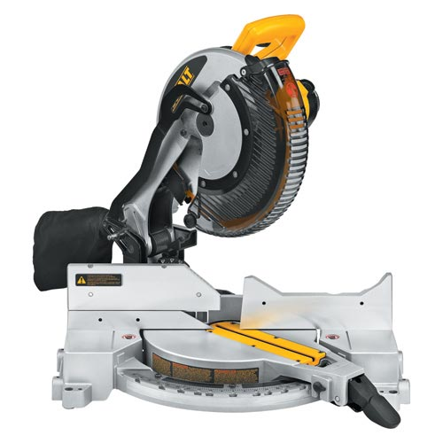
F
E
D
C
A
B
A

A. Miter Gauge B. Miter Locking Handle C. Bed D. Fence

E. Blade Guard F. Trigger

Working With the Saw

Before starting the cut:

• Remove sawdust from the bed. It may prevent an accurate cut.

• Place workpiece firmly against the fence.

• A solid grip is essential for safety and to prevent sideways creep.

• ALWAYS have your hand at least 6” away from the blade to protect your fingers.

Working Safe

• Always use safety glasses and appropriate clothing

• Always use the blade guard. If it works properly, it will retract smoothly as you make the cut.

• Always have a working electric brake.

• Always support long boards at the same height as the saw bed.

• Always observe a 6” SAFE ZONE for your hands.

• Always allow the motor to come to full speed before starting cut.

• Always allow the blade to come to a complete stop before removing wood or scraps.

• Always hold wood firmly against the fence.

• Always turn the saw off before making any adjustments.

Finishing the Cut

• Once the wood is cut the blade MUST come to a complete stop before raising the saw or moving the board or scraps.

• Keep fingers away from the cutting area until blade stops.

• The brake should stop the blade quickly. Inform your supervisor if it does not.

• Always recheck the length of your cut with a tape measure.

