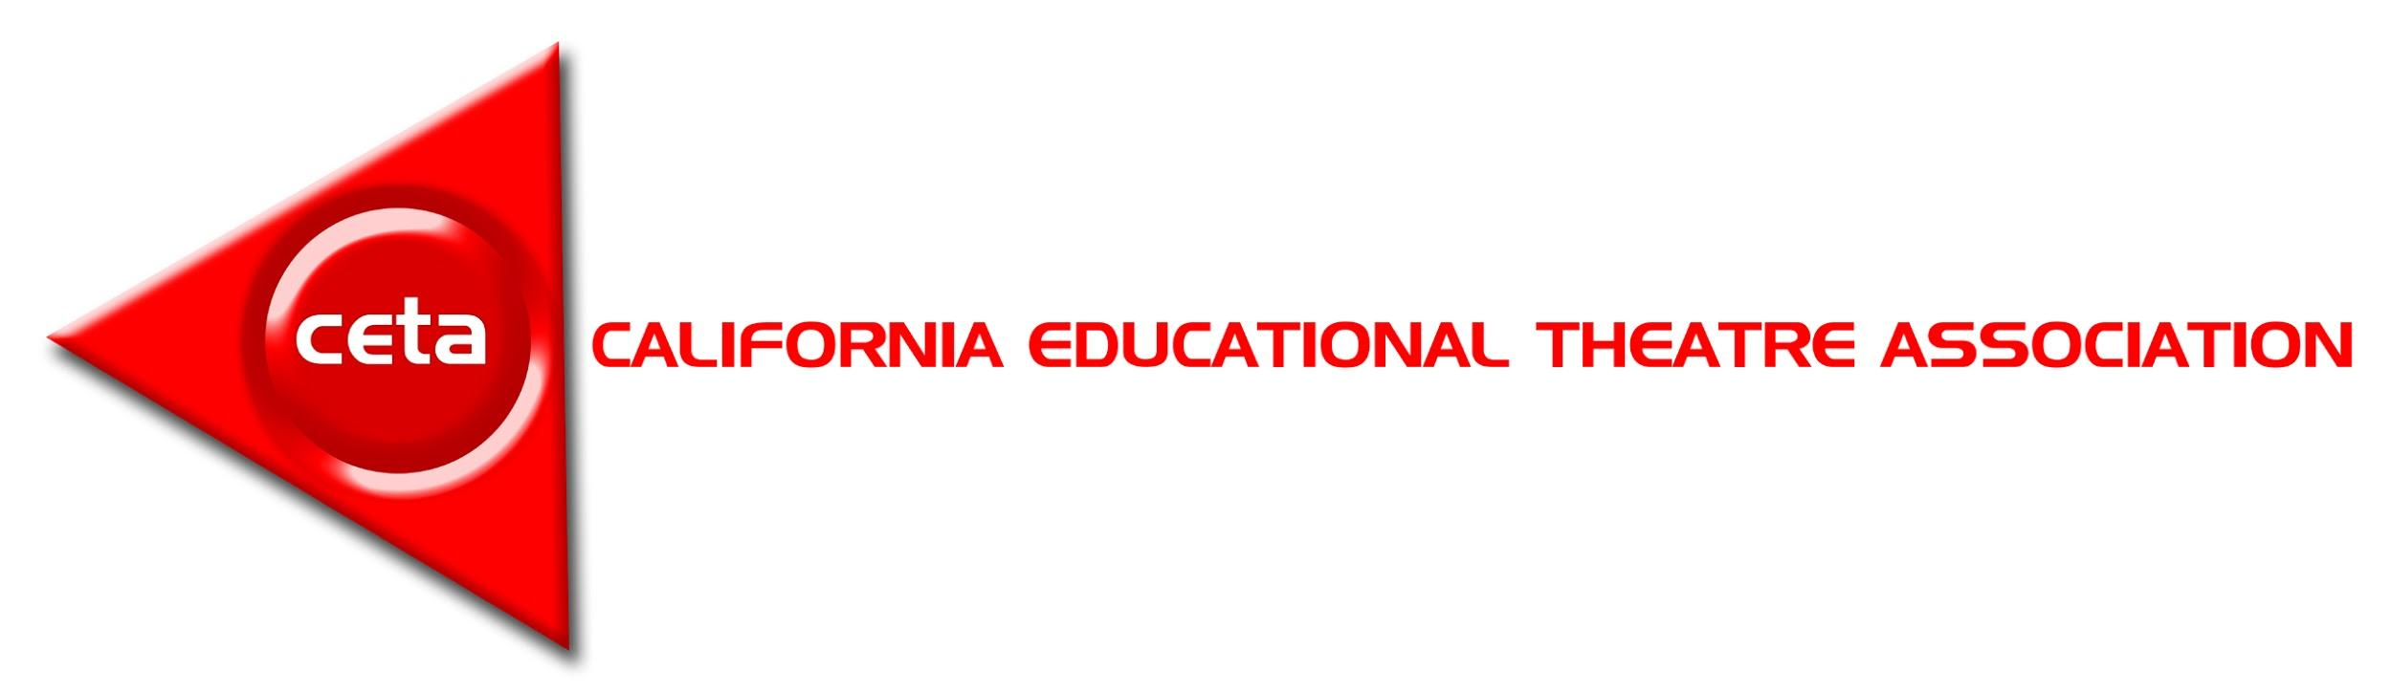
California Theatre Credential FAQ

The following document was modified from a document created by Jessy Kronenberg, CDEA Past President and CDEA Credential Task Force Director. It is designed to inform and update CA dance and theatre educators about the current status of the dance and theatre credential.
Please note the Commission on Teacher Credentialing is the final authority on all decisions regarding the credentials and credential procedures. .
______________________________________________________________________________________________

Acronyms:
CSET -- California Subject Examination for Teachers
This exam is a gateway into a Teacher Preparation Program Credential Program. It assesses content knowledge but not knowledge of pedagogy. This exam will be developed by a panel of experts in partnership with Pearson.
ETS Theatre PRAXIS -- The Praxis® tests measure the academic skills and subject-specific content knowledge needed for teaching. The Praxis tests are taken by individuals entering the teaching profession as part of the certification process required by many states and professional licensing organizations.
SMR -- Subject Matter Requirements
Developed by the CTC and a panel of content-specific experts, based on the content-specific teaching standards as dictated by Ed. Code, used by undergrad programs to prepare students to become candidates for credential programs.
TPE -- Teaching Performance Expectations
Developed by CTC and panel of experts, used by credential programs to guide teacher preparation and prepare students for successful internships and the Teaching Performance Assessment. Coursework toward satisfying the TPEs includes topics such as content-specific pedagogy, working with English Learners, assessment, social-emotional development, special needs students, lesson planning, parent engagement, and other such skills necessary to be a successful teacher in CA public schools.
TPA -- Teaching Performance Assessment
An evaluation that happens toward the end of a candidate's time in a teacher preparation program that assesses their ability to teach content standards and confirm that they have met TPEs.

CETA -- California Educational Theatre Association

CDEA -- California Educational Dance Association

TWO OPTIONS FOR ENTERING A CREDENTIAL PROGRAM

- A candidate can take and pass the CSET in Theatre to prove mastery of SMRs
OR
- A candidate can complete coursework through a Commission-approved Subject Matter Program (could be a “pre-teacher track” in a 4-yr program or a JC.) -- often about 24 units-- and would thus waive the CSET

SUBJECT MATTER EXAMINATIONS

California cannot just use the DELTA or the ETS Theatre PRAXIS because both assess knowledge of content-specific pedagogy alongside general content knowledge. According to CA law, our exams for entering credential programs (CSETs) are not to include content related to pedagogy. The intention is that the prospective candidate will learn that information while in the Teacher Education Program, and at the end of the program will pass the Teacher Performance Assessment (TPA) to prove competence in pedagogy as well. The exam consists of Multiple Choice items and Constructed Response items.

That said, Washington State, who also contracts with Pearson, has exams from which we may be able to cherry-pick certain test items as long as they align with our Subject Matter Requirements (SMR). Because the DELTA does not hold a contract with Pearson, it will not be useful to CA as it develops its CSET for Theatre.

A panel of subject-matter expert educators will develop the exam in partnership with Pearson; incentives will be offered to encourage volunteers to take the exam early to determine the passing standard; those volunteers will not get a passing score for this pilot of the test; if you pilot the exam or are a part if its development, you have to wait 5 years to actually take it and earn a credential.

EXPERT PANELS
The desire is for the panels to consist of a diverse group of theatre educators representing urban and rural districts from all regions of the state who are all well-versed in the new CA Arts Standards. They can be currently credentialed and teaching in the field as secondary teachers with Single-Subject credentials in English, Multiple Subject credentialed teachers who have focused in Theatre with supplemental authorizations, or retired theatre educators. The panel can also consist of individuals from the private sector who also have a clear understanding of the new standards and use them in their own educational setting as well as, university and Junior College professors, again, who are experts in the CA Arts standards.

Panels are for developing SMRs, TPEs, and CSETs.

“GRANDFATHERING”
The legislative language from SB 916, which was signed in to law in September 2016, states the following:
“A person issued a single-subject teaching credential in English before the establishment of a single-subject teaching credential in Theatre is authorized to teach Theatre.”
Also…
“Nothing in this section shall be construed to prohibit a school district from employing a person who holds a single-subject teaching credential in another subject with an authorization to teach...theatre from teaching theatre .”

CDEA and CETA continue to maintain this language as a basis for understanding the “grandfathering” agreements that accompanied the passage of SB 916 to establish single-subject credentials in Dance and Theatre in CA.

PE and English retain authorization for dance and theatre (grandfathering) for those who obtained the PE or English credentials before the formal establishment of the new credentials.

The CTC will clarify the procedure it will utilize to adhere to this section of the law.

CDEA RECOMMENDATIONS
CETA recommends that all Theatre educators in a public school setting in CA obtain the Theatre Credential, then add the English credential, and perhaps a CTE credential in Arts, Media, and Entertainment to ensure ultimate flexibility in employment. Note: Anyone in CA who holds a current credential in any subject is eligible to add any other subject by passing the CSET and taking a methodology course.

CTC TIMELINE
January 2019
  - State Board Adopts New VAPA Standards
    - Framework still in progress through 2019
  - A call for volunteer expert panels to form consisting of Theatre education professionals to develop the Subject Matter Requirements (SMRs) based on the new standards and the Teacher Performance Expectations (TPEs)
- January 2020
  - Adopt SMRs for Theatre
  - Adopt TPEs for Theatre
  - Begin work to develop the CSETs
  - As SMRs and TPEs are developed undergraduate Theatre departments can work on their "waiver" programs: those CTC approved programs that will waive the need to take a CSET; CTC is streamlining the waiver process
- Summer 2021
  - Exams finished, tested, and ready for official use
- Fall 2021
  - First cohorts of candidates enter Theatre credentialing programs throughout the state
- May 2022
  - First cohort of Theatre credential candidates complete credentialing

