Fall Arrest
How to Wear the Harness

A personal fall arrest system contains three parts, a full body harness, an anchor point capable of holding 5,000 lbs. and a connecting device.

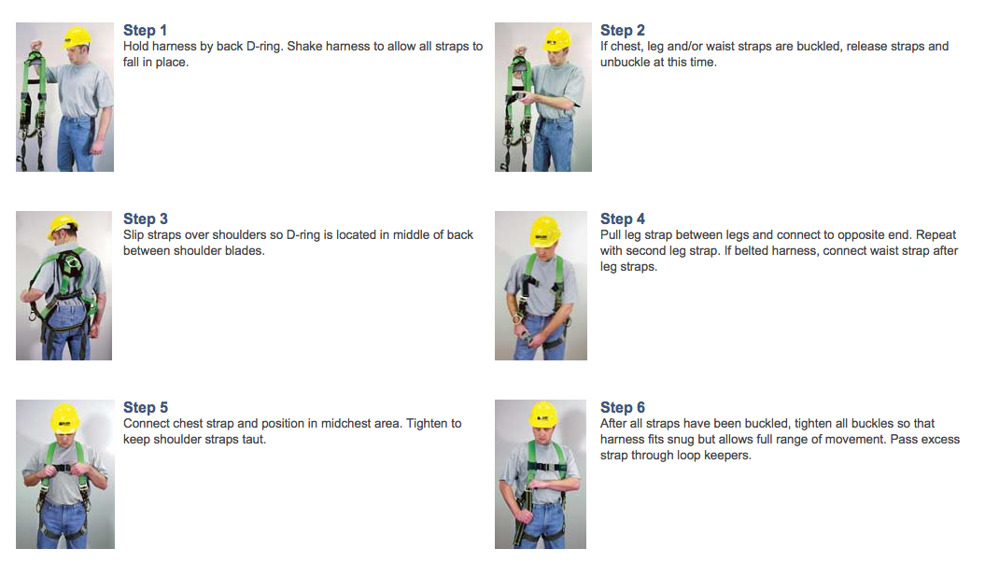

Clipping In and Climbing

1. Pull the self-retracting line by using the attached line.

2. Grab the black ball and then allow the line to retract slightly followed by a hard pull

3. The line (wire rope) should stop/lock immediately

4. Open the self-closing carabineer by twisting the latch.

5. Clip the carabineer to the D Ring on the back of your harness (be certain that hair and/or clothing are not obstructing the carabineer.)

6. Have your partner visually inspect that the latch is closed and attached to the D Ring

7. Climb the ladder (maintain 3 points of contact at all times)

8. When you reach the top of the ladder, swing the gate open and step through and close the gate behind you.

9. You may then unclip from the harness. Please control the speed of ascent of the retractable line.

10. When climbing down, follow procedures 1-7. When reaching the bottom, do not jump off the last rung.

11. You may then unclip from the harness. Please control the speed of ascent of the retractable line.

12. Remove the harness and return it to the rack.

Note: If you are afraid of heights, you do not have to climb the ladder but will need to demonstrate procedures 1-6

Practical Test

Demonstrate your ability to:

- Put on the harness correctly
- Follow guidelines 1-12

