Drill Competency Test

Name___________________________

Label the following diagram:

G

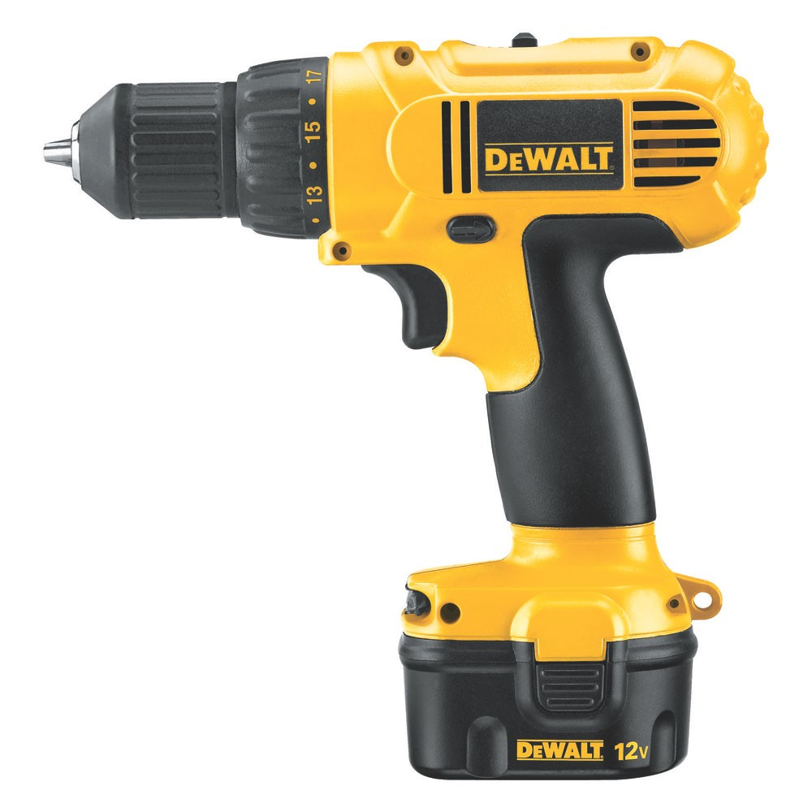
F
E
D
C
B
A

1. A.

2. B.

3. C.

4. D.

5. E.

6. F.

7. G.

Multiple Choice:

8.______The recommended angle for inserting a screw is____.

A. 45 degrees B. 70 degrees C. 90 degrees D. any angle will work

9.______To prevent splintering or breaking boards, use a ____

A. variable speed drill B. Pilot Hole C. wood screw D. higher torque setting

10.______Constant pressure isn’t advised when____.

A. screws are small B. drilling holes C. using a clamp D. putting in screws

True/False

11.______The chuck closes by turning it counter clockwise

12.______Start the drill slowly and then increase speed

13.______Safety glasses are rarely necessary

14.______Higher torque settings are recommended for longer screws

15.______The drill can go either forward or in reverse.

