Drill/Screw Gun Competency Information

G

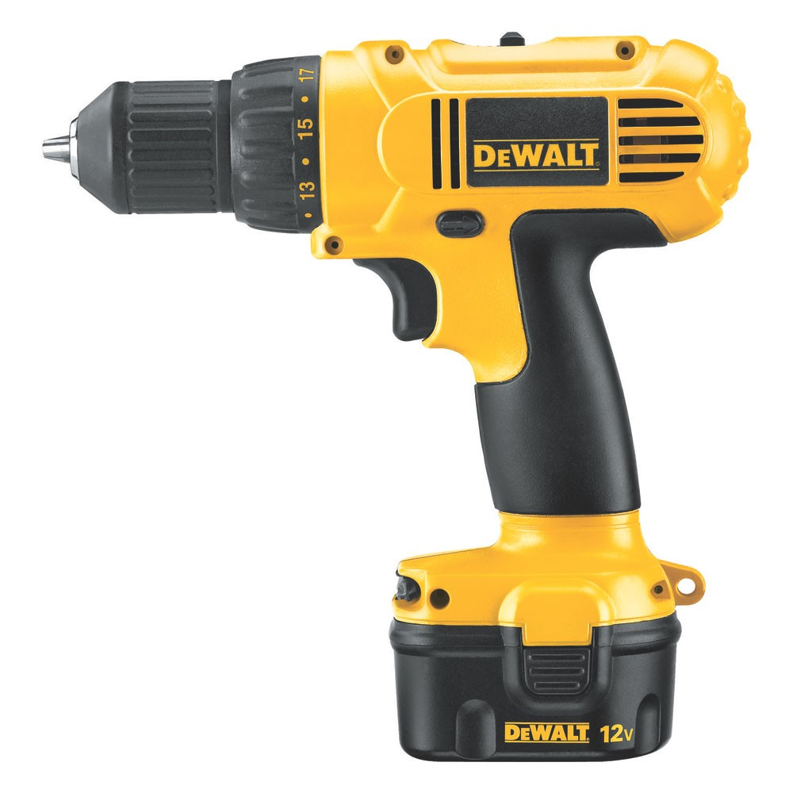
F
E
D
C
B
A

- Keyless Chuck
- Torque Control
- Trigger/Variable speed controller
- Battery
- Grip
- Forward/Reverse switch
- Gear switch

How to Use a Drill:

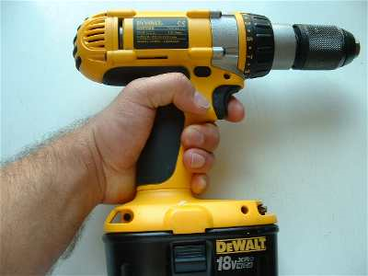
Drills can be used in either hand, the hand should wrap around the handle and the forefinger should be used to squeeze the trigger.
Forwards or reverse can be selected by pushing the selector switch with either my thumb or forefinger.
The trigger energizes the motor and makes the drill turn, always squeeze it gently.
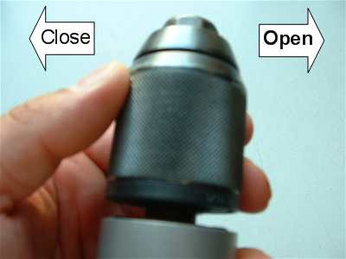
There are several different types of chucks but they are very similar, this one is all metal and can be opened or closed with just one hand. Most chucks require two hands, one to hold the back of the chuck and the other to twist the body of the chuck.
This particular chuck opens by turning the body of the chuck clockwise and closes by turning it anti-clockwise. Always ensure that the chuck is tight as a loosely held bit can damage the chuck!

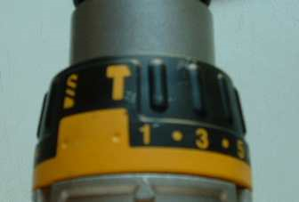

The torque / drill / hammer collar will be used frequently. This collar should be turned so that the pointer is pointing at what you would like to do. For drilling wood or metal turn it so that the pointer is on the drill symbol, for drilling masonry point it at the hammer symbol. The numbers represent Torque.
Torque settings allow the drill to stop at a specified Torque. The torque setting will stop the screw from going in too deep. In short, use the low setting for small loose screws and high settings for long, harder to turn, tighter screws.
Drill Safety:
1. Wear safety glasses.
2. Do not wear loose fitting clothing.
3. Wear clothing that will cover and protect your body, but not get caught up in the moving parts of the drill.
4. Use a dust mask if needed.
5. Hearing protection never hurt anyone.
6. Loose fitting gloves might get caught by moving devices.
Proper Technique:
1. Maintain your drill and bits
2. Clamp and secure whatever you’re working on as a general rule. Do not hold with your hands.
3. Pre-drill holes for woodscrews (Pilot Holes). This will help prevent splintering the wood.
4. Start slowly and slowly increase speed.
5. Maintain a 90 degree angle (perpendicular to the surface being drilled)
6. Vary the pressure and don’t let the drill bind when using a drill bit.
7. Keep constant pressure on the drill when putting in screws, preventing the bit from slipping within the screw head.
8. Don’t force the drill, let the machine do the work.
9. Slower speeds for thicker wood and high speed for metals.
10. Withdraw the bit often while drilling to remove chips.
11. Brush chips away, blow on them and they could end up in your eyes.
12. Use a side handle (if present) and hold the drill firmly with both hands.
13. Take your time

