Power Miter Saws
Written Competency Test

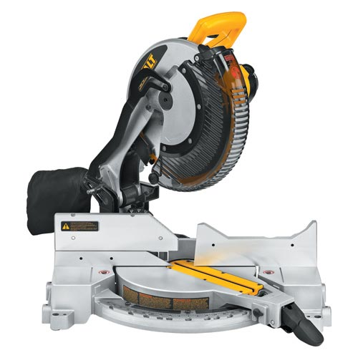
F
E
D
C
A
B
A

Fill in the blank:

1. A. 2. B. 3. C.

4. D. 5. E. 6. F.

Multiple Choice

7.______The safety zone around the saw is____.

A. 4” C. 8”
B. 6” D. 10”

8.______Wood should be held flat against the bed and firmly againt the____.

A. Blade Guard C. Fence
B. Trigger C. Miter locking handle

9.______The motor should be a____speed before starting a cut.

A. One Quarter C. Full
B. Half D. Doesn’t matter what

10.______Be certain that the____before removing the cut board.

A. blade has stopped C. sawdust is not covering the cut
B. board looks good D. pencil mark is still visible

T/F

11.______A miter cut is any angled cut.

12.______Safety glasses are usually required.

13.______What the saw blade “takes away” is called the kerf.

14.______Adjustments to the saw and/or blade can be made with the saw running.

15.______Use of a jig can enable you to more accurately make multiple cuts of the same length.

