Safety Speed Cut
C4 Panel Saw

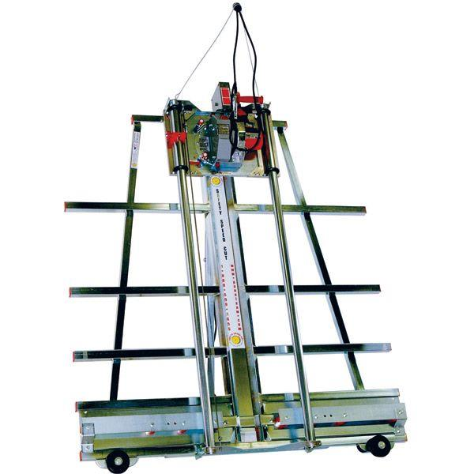

Overall Layout

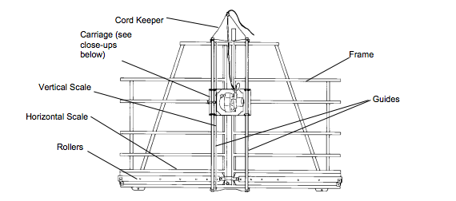

Carriage and Saw
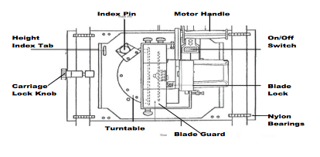

General Operating Tips

- When you feed the material through the tool horizontally, or move the carriage over the material vertically, do it slowly, smoothly, and when possible without stopping. Overfeeding results in poor quality cuts, shorten blade life, and motor overload.
- Panels being cut horizontally or vertically must always be fed against the rotation of the saw blade.
- DO NOT FORCE THE TOOL. Let the saw do the work.
- SECURE WORK PROPERLY. If a piece is supported on both sides of the cut in such a way that it allows the material to bow and pinch the blade, it may produce kickback.
- Do not cut pieces smaller than the saw carriage. Support large panels properly.
- IF THE BLADE BINDS, the saw or work piece may kick back. Keep hands, body, and bystanders out of the path of the blade and material.
- STAY ALERT. Watch what you are doing and use common sense. Do not allow yourself to be distracted.

Crosscutting (Top to Bottom)

A crosscut is a cut from the top to the bottom of a work piece.

- Position the saw in the crosscutting position with the blade oriented vertically.
- Loosen the carriage lock and move the carriage to the top of the guides.
- Place the work piece on top of the rollers. Do not drop the materials onto the rollers.
- Slide the work piece to the desirable position.
- Make sure the work Piece is secure in the machine. You can hold the piece with one hand. Do Not hold the work piece so that your hand is anywhere behind the carriage or guides or in the path of the saw blade.
- Start the motor and allow it to reach full speed.
- Slowly and smoothly pull the carriage down so the blade runs through the work piece. Do not force the saw through the work piece to avoid binding. If the blade does bind, or the work piece shifts during the cut, stop the motor, move the carriage to the top of the guides, restart the motor, and begin the cut again.
- Support and remove the cut-off piece as the saw completes the cut.
- When the cut is complete, turn off the motor and wait for the blade to stops completely. Move the work piece away from the blade and return the carriage to the top of the guides and lock the carriage rip lock.
- When making cuts less than one inch, the chatter guard must be resting on the work piece not on the cut off piece.

Rip cutting (Left to Right)

Rip cuts must always be done by moving the work piece in the direction of the arrow on the saw carriage.

- Before you begin, be sure there is enough space on both sides of the saw to completely load the work piece on the saw frame, move it past the saw, and completely off-load it.
- Select the ripping direction, from right or from left. Then rotate the turntable to the ripping position. Select the height of the saw blade above the rollers. Raise or lower the carriage until the height index tab is aligned with the corresponding dimension on the vertically mounted ruler and lock the carriage to the guides.
- Start the motor and let it reach full speed.
- Position the material on the side of the machine indicated by the arrows on the carriage that show the direction of the cut. Place the work piece on top of the rollers being sure not to drop it onto the rollers.
- When the motor is at full speed slowly and smoothly push the work piece into the saw in the direction of the feed arrow on the saw. Avoid placing hands, clothing, or body parts under the carriage or in the path of the blade. Do not look directly down the line of cut because dust will generate.
- As the work piece passes across the machine, move to the other side of the machine and finish the cut by pulling the work piece through the blade. Make sure you support the top piece to keep it from pinching the blade or kerf protector, or falling from the machine.
- Once the cut is done turn the motor off and wait for the blade to stop completely and then remove the work pieces from the machine.
- Rotate the turntable back to the vertical position and return the carriage to the top of the guides and lock it in this position.

Safety Tips:

- Wear appropriate clothing
- Wear safety glasses
- Wear dust mask if cutting Masonite or similar materials
- If doing more than five Rip cuts, use hearing protection
- Keep hands away from the underside of the carriage
- Do not attempt to make cuts of less than 1”
- Stop saw when finished with cuts
- Stop the saw to remove debris from rollers
- Stop the saw when making adjustments
- When performing Cross cuts, pull/push downward on the saw and not toward you.
- Sweep up after use or when doing extended work. Sawdust is a slip hazard.

