Single Purchase Counterweight Systems
Information and Procedures

The following information is designed for a single purchase counterweight rigging system without a loading gallery/bridge.

System Components:

Counterweight Arbor
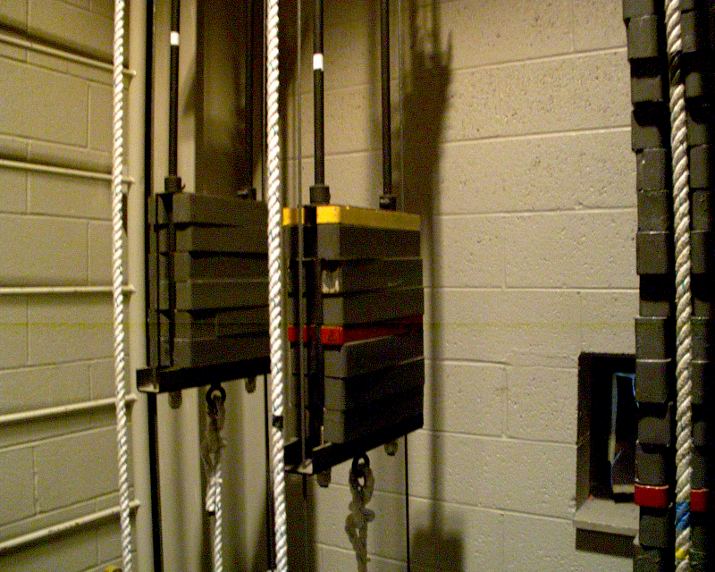

Counterweights
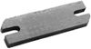

Arbor Rods/Spreader Plates 24” and Locking Collars
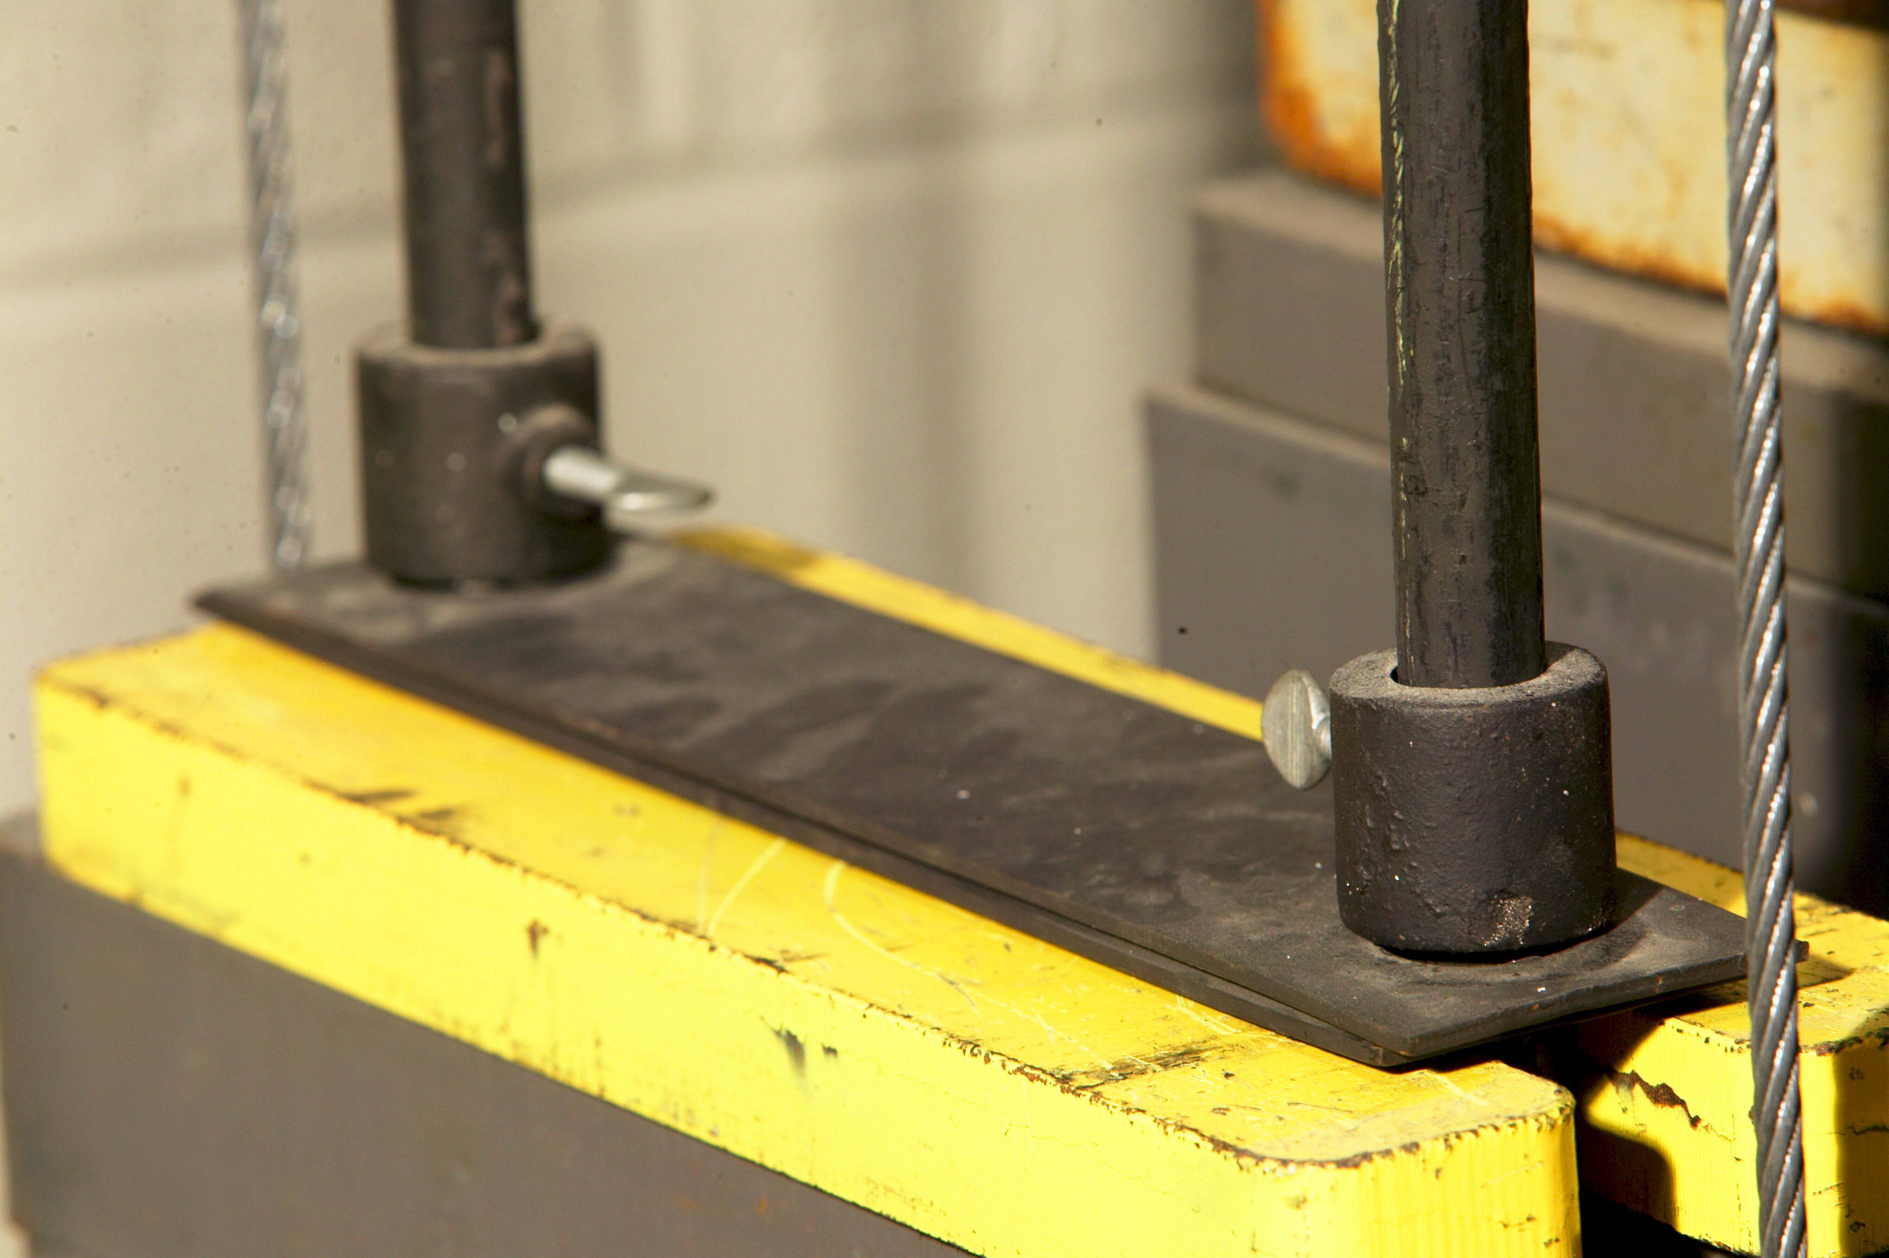

Hand/Purchase Line

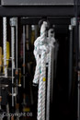
Rope Lock
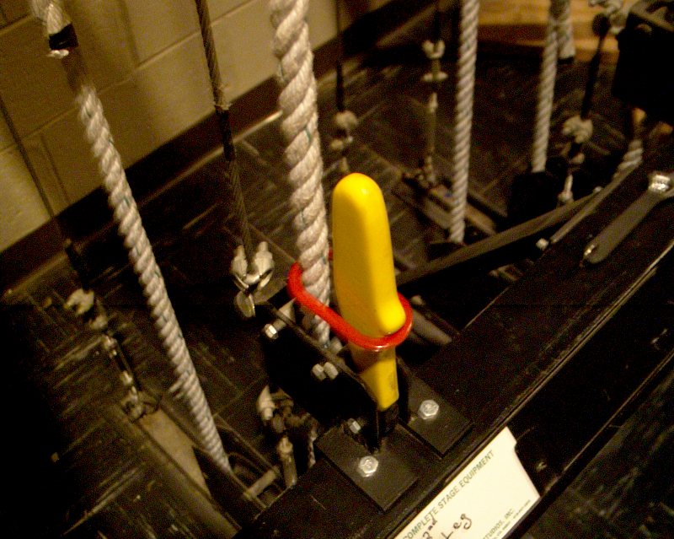

Lift Lines
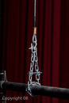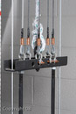

Battens
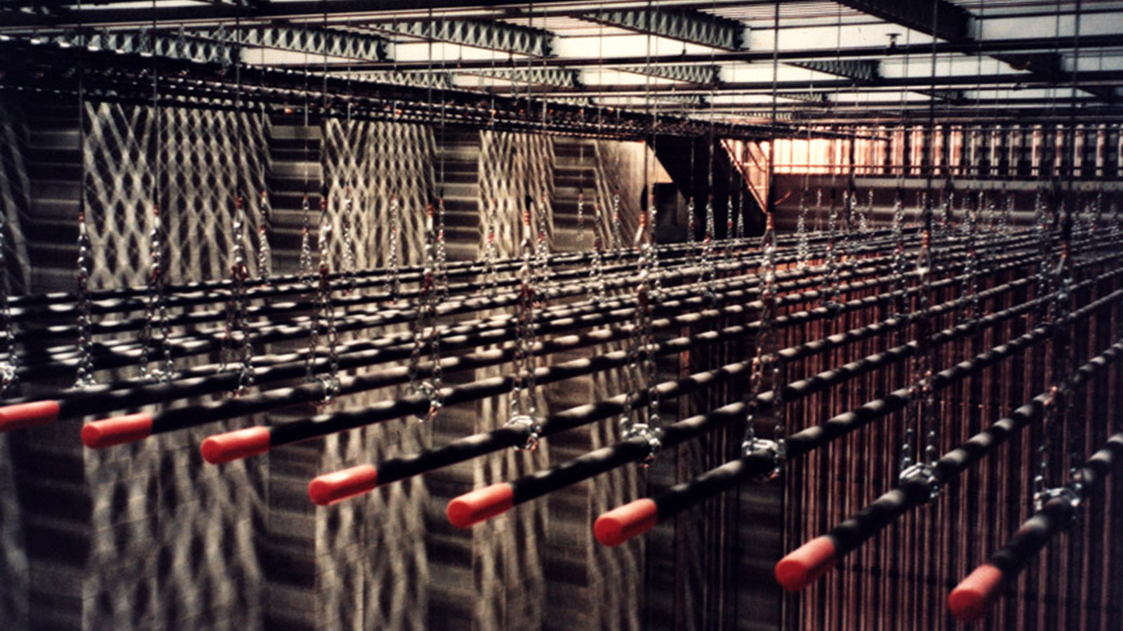

Locking Rails/Index Strip
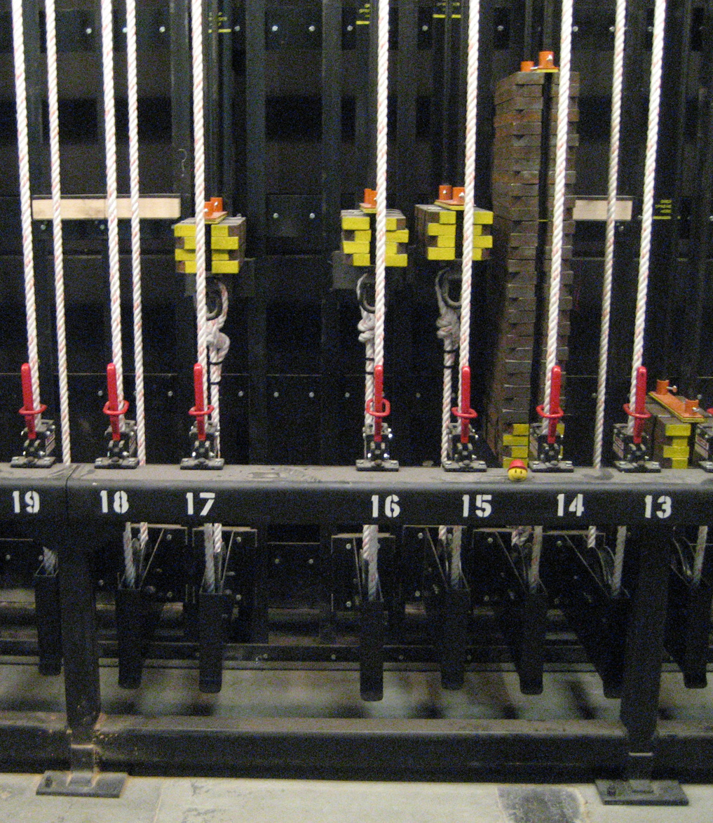

Procedures for Operating a Single Purchase Counterweight System

- Before opening the rope lock, check the hand lines above and below the arbor.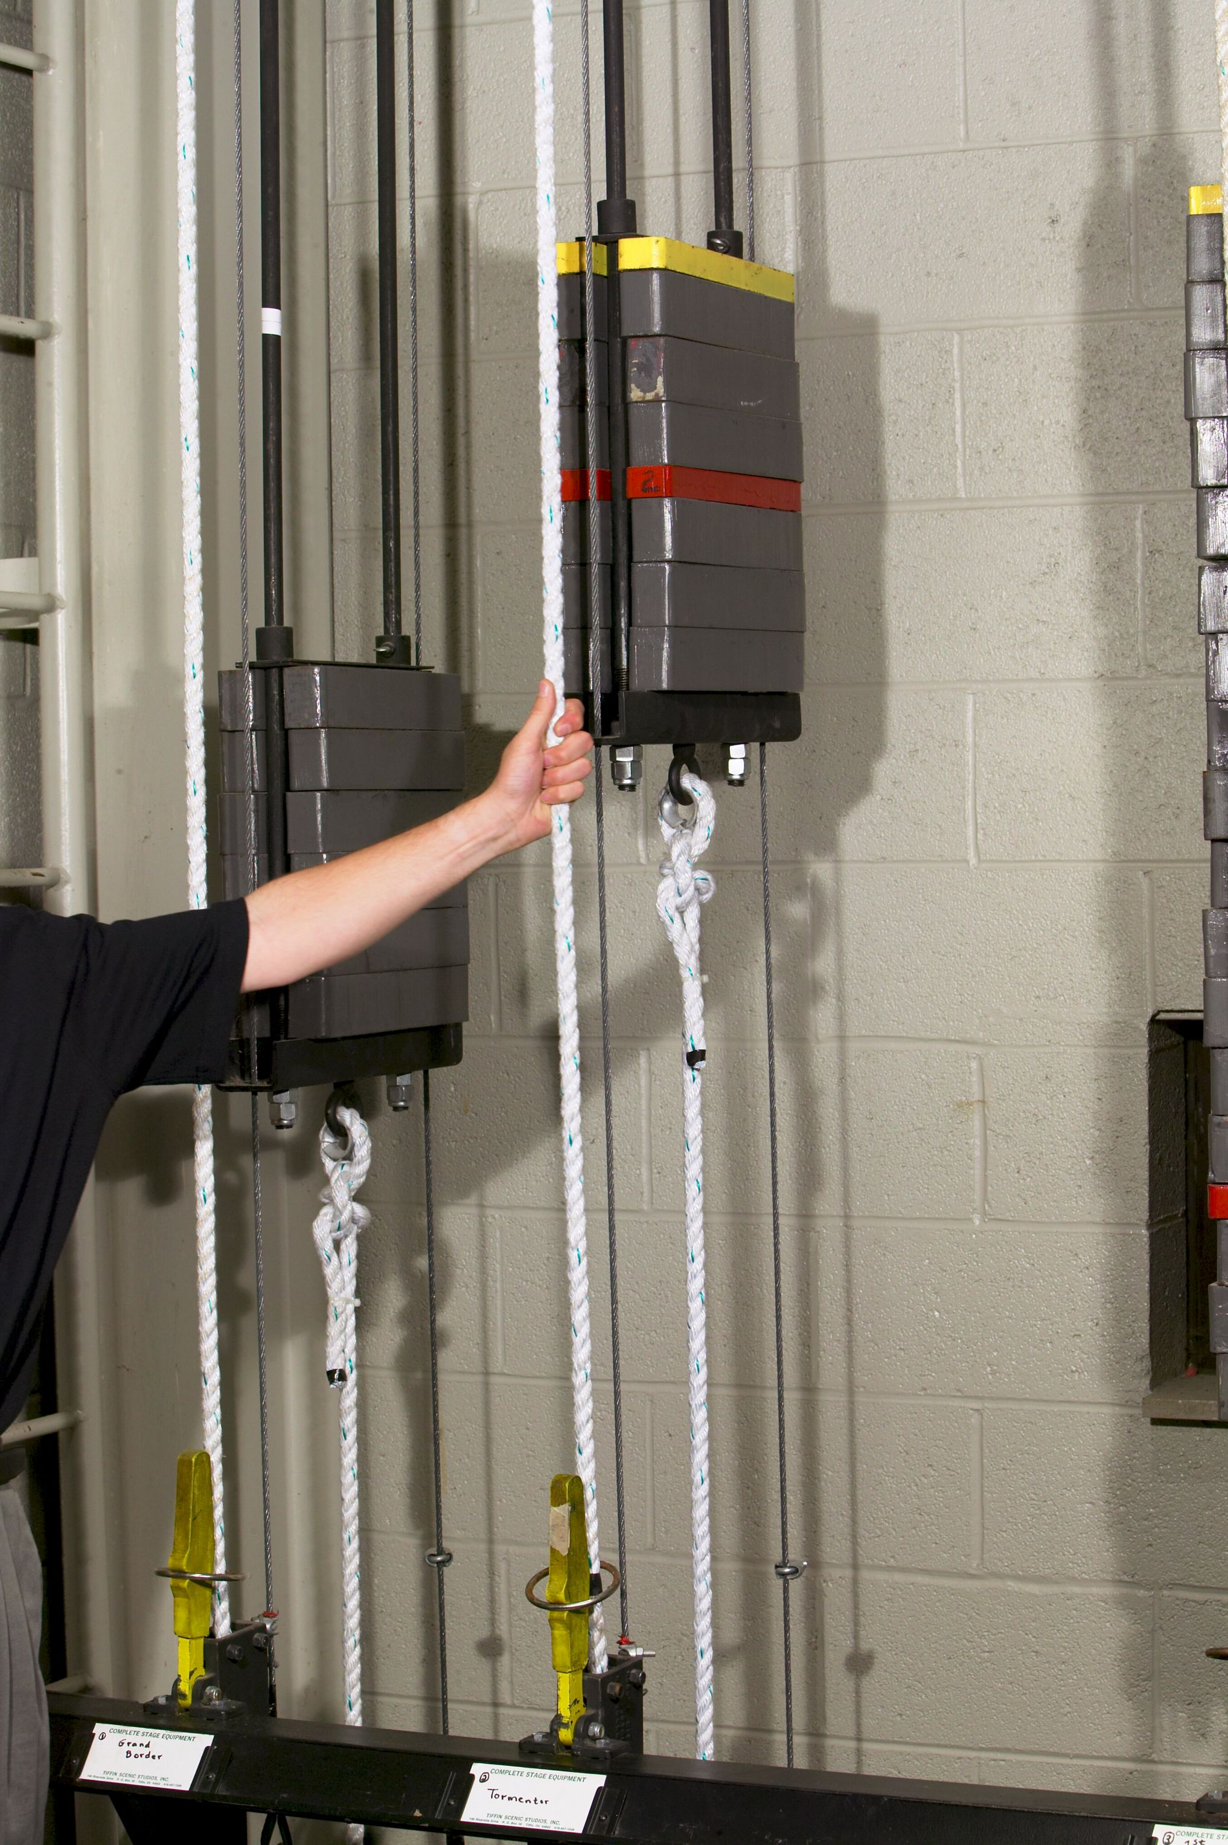

Excess tension above the arbor indicates that the line set is arbor heavy. While excess tension below indicates that the set is batten heavy.

- Once you have determined that the set is in reasonable/controllable balance
visually determine that there are no obstructions or people in the path of the batten and call loudly “line set # coming in!”. In our theatre, people working in the stage area respond with a loud, “thank you!”

- If you are putting lights, curtains or scenery on the batten, you must be aware of the weight of the new load and then plan accordingly. Although there is no danger in putting weight on a batten in the “in position” as any balance/safety issue is mitigated due to the position of the arbor and the batten, there is an issue with returning it to the “out position”. Consider how much weight one person (ot two) can reasonably control when raising the batten and then re-weight the arbor in a safe incremental fashion. Rope locks, by design, should be able to hold up to fifty pounds out of balance, but if you are 100 lbs. out of balance, then someone is holding down the arbor while someone else is loading counterweight right over their head. (not safe).

We generally hang 40-50 lbs., take out the batten, re-weight and repeat. It takes longer but it is safer method.

4. When removing weight from the batten, follow a similar method. Incrementally, take weight off the batten and then the arbor.
5. Remember, each time you move the batten/arbor, make a call alerting people in the stage area.

Loading/Unloading the Arbor

- (Be certain to wear gloves).When you are ready to add or subtract weight from the arbor, loosen the the thumb screws on the locking collars and move the speader plate and locking collars high enough up the arbor rods to allow easy access to the top of the stack of counterweights. Clip the spreader plate into place with a spring loaded clamp. If you are loading the arbor alone, be certain that you can control the counterweight using both hands (don’t go higher than chest height.) If working with a partner, be certain that you have a clear system of communication if you are passing weight one to the other.
It is acceptable to load/unload additional weight (max. 50 lbs.) for the next action but be aware that the set is temporarily out of balance.

