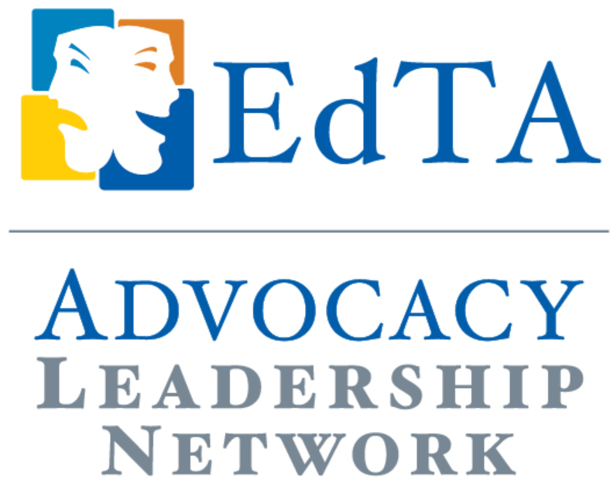
Case Study

How to Secure a Local or State Arts Day Proclamation
Michael Daehn, EdTA ALN Representative, Indiana Thespians
The proverbial cherry on top of a state advocacy day or major local arts event is an official designation of the day by the mayor or state legislature. It’s a simpler process to get such a proclamation for your advocacy event than you might think.
With a reading of a mayoral proclamation, here’s all you need to do. Simultaneously, email the mayor’s chief of staff or designated education staff member, and make your request. If you live in a smaller city, you should email the mayor themselves. In both cases, ask for a short meeting (10 to 15 minutes), where you can present your arguments for the special designation. Come prepared to the meeting with facts that show the transformative nature of academic theatre nationally and personal stories about local victories that back them up. Finally, offer the mayor the opportunity to kick off your special event by reading their proclamation to your gathered public (who are also voters). If the mayor seems undecided after the meeting, contact your own city councilperson and ask for their help. Let them know what you’re trying to do and see if they’ll intervene on your cause’s behalf. They might be able to provide that essential last little nudge across the finish line.
If you are planning a state-wide theatre (or arts) advocacy day and seek your state legislature to recognize and honor your efforts with a proclamation, any representative can enter such a resolution in the house (assembly) and any senator in the senate. You simply need to set up a meeting with your Representative/Senator or their relevant staff member (they will respond to your email or call). If they are not arts supporters, then simply seek the assistance of an arts supporting representative and senator from a different part of the state. In either case, they will enter your official proclamation into the public record in the form of a bill which will be voted in unanimously by acclaim.
If you are a small group, you may be brought before the entire bodies of legislators for recognition and applause. If you are a large group, you will be asked to stand in the gallery as your proclamation is read. It’s a great climax to a state arts advocacy day. You may also request a written copy of the bill.

