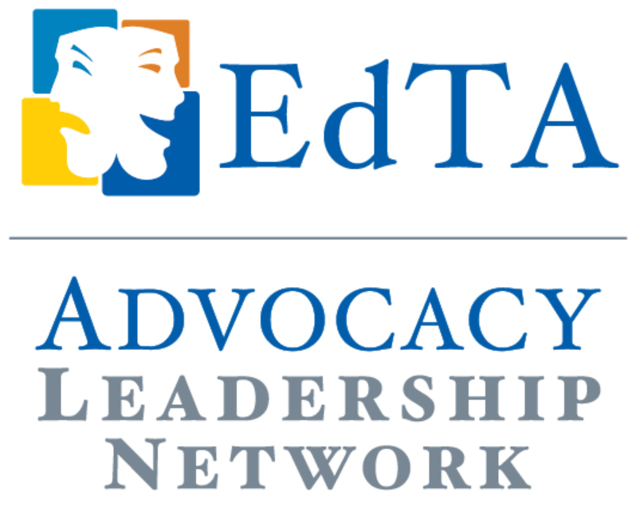
Case Study

A Student-led Advocacy Workshop
Kate Torcom, EdTA ALN Representative, Oregon Thespians
This fall we instituted a student-written/led advocacy workshop at our Thespian Troupe Officer (TTO) training event, “Camp Thespis: A Leadership Summit”. Our State Thespian Officer (STO), Alex Mehigan ran this workshop 5 times over the course of the event to ensure that all interested students could attend. Prior to the event, Alex sent the Oregon Adult Board his working drafts of this workshop and we edited it together. One month out from the event, Alex practiced presenting the workshop to another STO and me. We provided feedback on both execution and the workshop itself to Alex, who incorporated these notes into his piece. At Camp Thespis, Alex presented his workshop successfully and encouraged advocacy discussion amongst students.
Here is a reflection from Alex on his workshop:
Last month, at Camp Thespis: A Leadership Summit I taught a workshop entitled, “Advocacy: What, Why and How.” The theatre students that attended seemed to be very energized by the idea of advocating for Theatre Education. They were attentive, focused, and overall very responsive! With more exposure to advocating (workshops like these, emailing congressmen, capitol days, etc.) I believe that more and more high school Theatre students will WANT to be involved in advocating for what they love, and often depend on.

