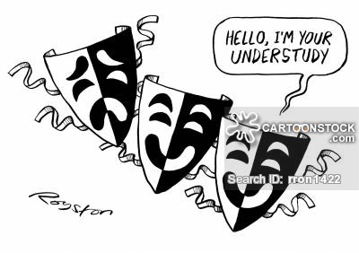

The job of an UNDERSTUDY
Here is a quick guide on how to be the perfect understudy, and who knows, maybe next time you’ll get the lead!
#1: Highlight your lines.
#2: You will also go off script the same time as the principle actor.
#3: You will be a “shadow” to the part you are understudying for on stage. This includes: taking notes about your character, blocking, and notes that the director says to write in the script (like your verbs).
#4: If the person is gone and you are filling in their spot. Take all changing in blocking and any notes the director gives you in your script.
#5: Act as line coach. Everyone needs help to learn lines, and one of the best ways to lean the lines yourself, is to go over them. So be a line coach for the part you are understudy for.
#6: Act as table work guide. You will be in charge of feeding lines to your actor during scene work, when the actor goes off book, and during movement work.
Being an understudy may sound like a boring job, but it involves a lot more work than most people believe it does. Learning lines, movement, and filling in for the part(s) if the other actor or actress isn’t there can be a tough thing to do.
A lot of work goes into a show, and an Understudy is a huge part of that process…
…and just think, if the actor misses too many practices, you may find yourself in a new role!

