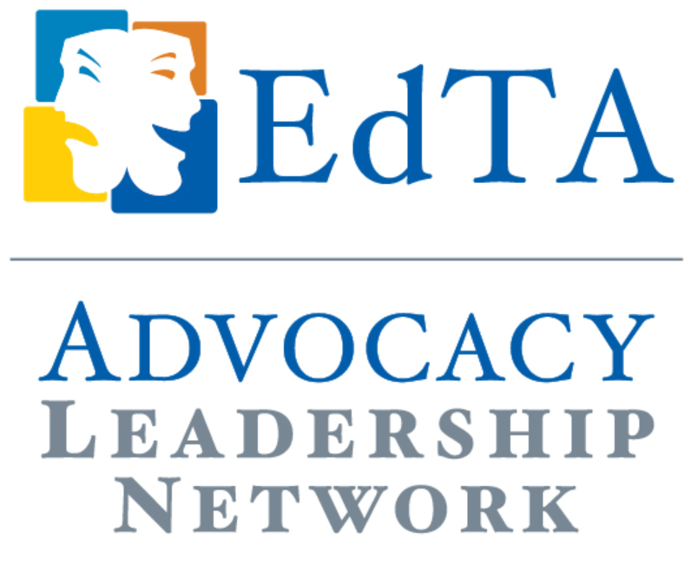
Case Study

The Art of Making an Ask
Michael Daehn, EdTA ALN Representative, Indiana Thespians

I) What is an ASK?
An ask is a well prepared, highly specific request made by an advocate to a policy maker which focuses on some perceived important want or need. Careful preparation of the ask and sufficient practice on just how to deliver the message are essential to potential success by any advocate on any topic.

II) How do you Craft Your ASK? Key questions to answer first:
*What is the issue? Clearly identify the issue or need that you seek to be addressed in your school, district, state or nationally.
*Who has the ability to solve this problem or address this need? What can you learn about this/these stakeholders and how/why they might respond to your request in a particular fashion?
* Who else can you get to partner with you in your efforts? Who else might have similar feelings about your issue? There is certainly considerable power in numbers when it comes to making your voice heard – and remembered!
* What is your timeline for action? What resources do you need?
* What does success or positive change look like for you and your cause? How do you know if you and your partners are ultimately successful? An ASK must be measurable.

III) Making your ASK Concrete
The formula for turning the information you have gathered in the above steps into a successful ASK requires a two pronged approach which blends the quantitative power of data with the empathy inducing abilities of heartstring tugging stories. In other words, you need to provide compelling data from studies, reports and articles but they should be coupled with touching or powerful stories on the salient subject. This way, both mind and heart are engaged by your ASK.
Again, make sure that what you are asking for is very specific, clearly shared, and that the policyholder has a copy of your specific request (what’s known as “a leave behind”)

IV) How do you measure success?
Hopefully, the policy you are asking to be changed undergoes some significant, positive adjustment after your advocacy efforts – maybe in full, maybe only in part. Either way you successfully advocated for change and the end result was change. However, if that doesn’t happen initially, advocates are persistent and will continue the dialogue until they DO ultimately achieve their goals. Also, it is important to remember that every ASK is successful in at least one substantial way – in the process, you are developing an evolving, personal relationship with a policymaker - that makes them more predisposed to listen to what you advocate without filters both now and in the future. That is also what success looks like!

Additional Tips When Making Your Ask
- Be Polite! The stakeholder has been generous enough to provide time from their busy schedule to listen to you
- Know your stuff well! Be aware of which arguments are likely your strongest. It also helps to research the stakeholder to learn which aspects of their lives/backgrounds might make them more amenable to some lines of discussion than others
- Don’t bring up other non-ASK related subjects. Stay on task unless the stakeholder temporarily changes the subject to an equally attractive topic for your needs. A discussion on your opposing views about climate change might derail your arts based ASK (the purpose of the meeting)
- Stay positive and likable. You are more likely to get a similar response.
- Make sure you follow up after the meeting with a thank you email or card and any additional information you promised to provide later. This should be sent or delivered within days after the meeting.

