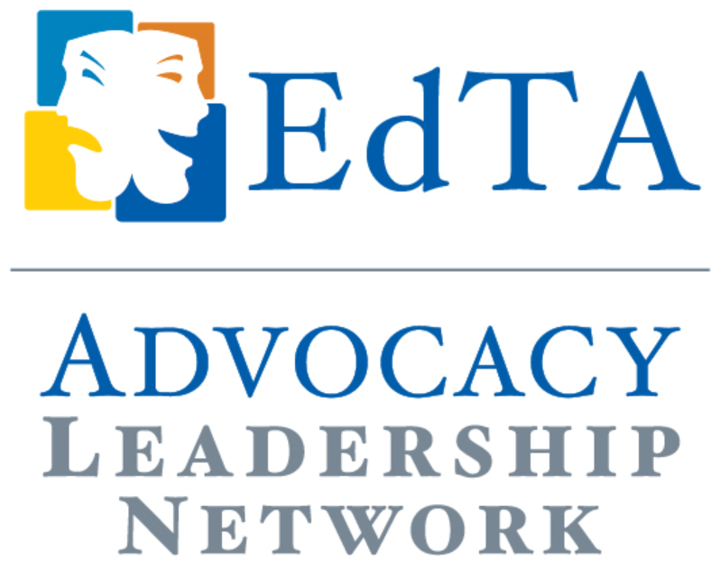
Case Study

A Chapter Advocacy Fundraiser
Helen Duranleau-Brennan, EdTA ALN Representative, Iowa Thespians
In Iowa, we recently came up with a model to fund our student and adult advocacy work. As Iowa Thespians currently does not have sponsors except for vendors at our festival. We offer three Thespian scholarships and have been trying to determine how to make the scholarship program more substantial so we could offer more scholarships or increase the existing ones.
As the Iowa Advocacy director, I recognized that we needed to support:
- Advocacy on the local, state, and national level. This support involves travel, food, registration costs, as well as materials development. Although Iowa Board did approve some funds for Advocacy efforts, additional funds need to be generated for us to be successful in our efforts.
- Student advocates. Two years ago, we launched our own Democracy Works contest two years ago, awarding $1000 to a student to travel to DC and have a hands-on advocacy training at the National Arts Action Summit in Washington. Students can be powerful in legislative efforts as they relate their own stories about how theatre/arts have impacted their lives.
- Next generation teacher advocates. This year, in addition to sponsoring a high school student in March, we recruited a college student and absorbed her costs to attend the 2019 EdTA Advocacy Day. When our Iowa delegation goes to Washington, D.C. in March, I hope to bring at least one high school student, one college student, as well as the current Miss Iowa, Emily Tinsman, a music educator whose platform is Arts Education Advocacy.
Emily, a graduate of Bettendorf High School and Thespian alum, reached out to me to ask how she could support Iowa Thespians advocacy efforts. We met to discuss what our partnership could look like and, as Emily is an accomplished vocalist, decided on a concert format. Because cultivating attracting alumni is an important organizational goal, I suggested we make this an alum focused event.
I contacted some Iowa arts educators as well as former students of mine to build to help work out the details. One committee member is donating the performance space, a former student donated the post-event party space and a donation, another donated the design work for posters, flyers, etc. through his design company. Our emcee is a former theatre student of mine. I drafted a letter that our chapter director sent to all Iowa Thespian directors that that asked them to recruit their talented alumni to perform in this event. Soon the interest was generated, and alumni contacted me about performing in this event. Currently, we have 10 high schools represented with approximately 15 performers, singing iconic Broadway songs. We also will recognize Iowa Arts Advocates as “Honorary Committee” members from across the state at this event.
We believe we have created a sustainable framework that can fund Iowa Thespian advocacy for years to come. We are planning on expanding the event for next year, assuming this event goes well

