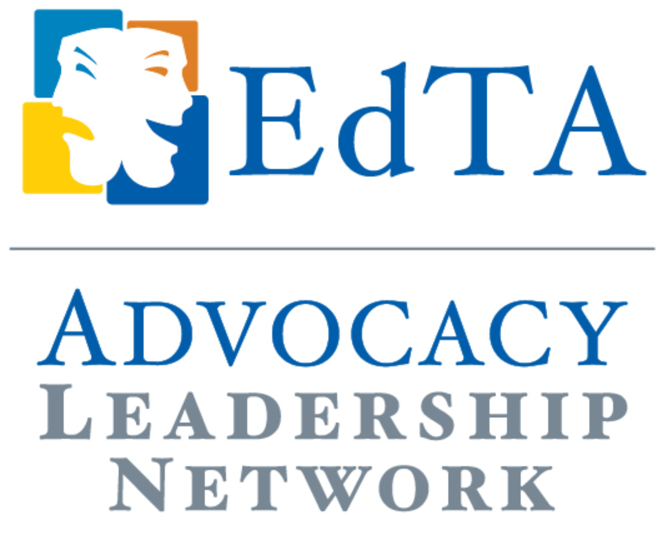
Case Study

Advocacy workshops as professional development for Troupe Directors
Kate Torcom, EdTA ALN Representative, Oregon Thespians

At our annual Oregon Theatre Educators Association conference (OTEA), we added a large section on Advocacy for our troupe directors. The event was a relatively simple concept and could easily be replicated. We titled the event “Advocacy A La Carte” as it was a sort of buffet of different notions regarding advocacy. Three different speakers were invited and given twenty minutes to present, this was followed up by time for round table discussions with the individual speakers. This format allowed for the full group to hear from each speaker, but then opt into whatever follow-up conversation they felt the most intrigued by. You can choose speakers that fit the needs of your group, our speakers covered the following array: how to use a new measure to get more theatrical funding at your school, ways to incorporate advocacy in the classroom, and how to get involved with advocacy with your local institutions. This workshop concluded with a mini lesson on “The Power of the Thank You Card” (see my other Case Study) and troupe directors wrote “thank you” notes that we then mailed for them.

