Excel based CAST PAGE

This cast page was created using Excel. It uses the Calibri font and “wing dings” that come with it. The ITS logo is in the excel template and also available in the ITS website teacher pages under resources.

- Once the excel table is complete, on the PAGE LAYOUT tab, select the area you want to copy to MS Word, then un-check the View Gridlines box.

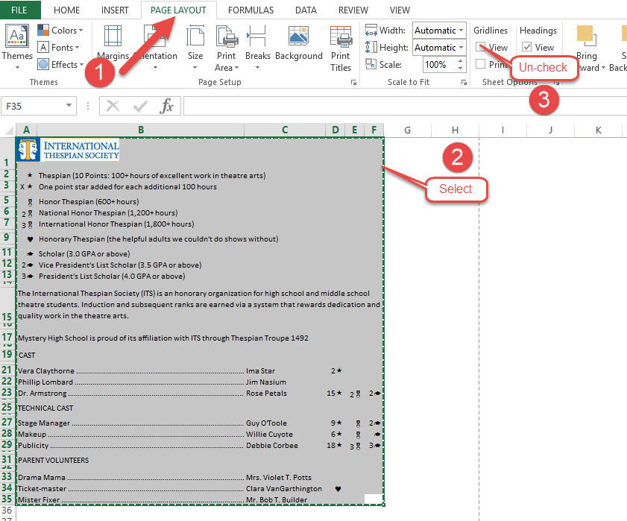

- Click the HOME tab then click “Copy”

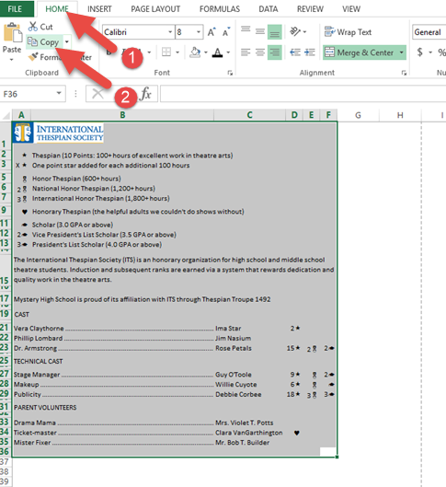

- In a Word document, click Paste, then Paste Special

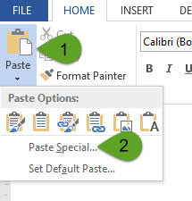

- Choose Microsoft Excel Worksheet Object then click OK

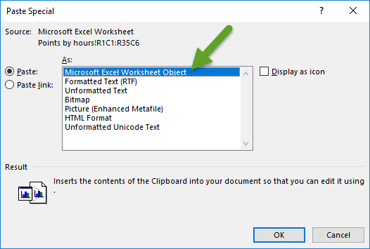

- Your cast list is still editable in the word document by double-clicking it to reveal it as an excel table.

