Drama Isn’t Just Acting!
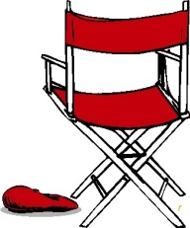
Crew work is an important part that keeps the show going! There are any aspects and every single one matters. Without you the actors wouldn't have a set, make-up, costumes, or even lighting! If you’re interested in helping come see Mrs. Dommer or Jennifer Culver, they can answer any of your questions and tell you where to go.

Publicity- You work on getting people interested in coming to see the play! They put together a radio ad and also put the program together for the show.

Props- As the name implies you will find props for the show and make places for them. Actors are in charge of keeping track of their own props!

Set Construction- You help build the set! Working with Bob you will learn how to put together walls, floors, and paint the set! Skills needed: listening and motivation!

Lights- Setting the stage lights
Sound- Includes sound cues, music, and microphones used on-stage.
House- Includes taking tickets, watching doors, handing out programs and cleaning up after the show.
Set Shifting- Moving the set between scenes!
Stage Managing- Keeping the actors on track! Making sure they are ready for their entrances and making sure practices runs smoothly for everyone. You’ll make sure what Natalie wants gets taken care of! ☻

Make-up- Helping people both apply and find their correct base and features, as well as applying final seal! Also includes helping fix make-up during intermission.
Hair- Helping style and maybe learn wig application!

You don’t need experience to do any of these, you’ll learn and get better as you go!

